

**Computer Games Technology**

A JavaScript Runtime for Hardware Accelerated Applications

**Computing Honours Project (COMP10034)**

**Project Management Report**

William Taylor

**B00235610**

12/03/2017

**Supervisor: Paul Keir**

Table of Contents

1.0 Management Overview 3

1.1 Work Plan 3

1.2 Gantt Charts 3

1.3 Version Control 4

1.4 Online Repository 4

1.5 Statistics 5

2.0 Supervisor Meetings 6

2.1 Meeting 1 6

2.1.1 Meeting Agenda 6

2.1.2 Meeting Minutes 6

2.2 Meeting 2 6

2.2.1 Meeting Agenda 6

2.1.2 Meeting Minutes 6

2.3 Meeting 3 6

2.3.1 Meeting Agenda 6

2.3.2 Meeting Minutes 6

2.4 Meeting 4 6

2.4.1 Meeting Agenda 6

2.4.2 Meeting Minutes 7

2.5 Meeting 5 7

2.5.1 Meeting Agenda 7

2.5.2 Meeting Minutes 7

2.6 Meeting 6 7

2.6.1 Meeting Agenda 7

2.6.2 Meeting Minutes 7

2.7 Meeting 7 7

2.7.1 Meeting Agenda 7

2.7.2 Meeting Minutes 7

2.8 Meeting 8 7

2.8.1 Meeting Agenda 7

2.8.2 Meeting Minutes 7

3.0 Conclusion 8

# Management Overview

A lot of work went into managing the work in this module as there was a lot to do. To ensure a smooth head start to the work a lot of research happened before the start of the module. This ensured that the software development and the Interim report could be finished in Trimester 1. This allowed plenty of time to spend on the final honours report and presentation in Trimester 2.

## 1.1 Work Plan

The strategy was straight forward, complete as much work as possible before the start date to ensure plenty of time to spend on the academic writing and research end of the project. I for one saw the fact that the final honours report and development work was meant to be done in trimester two at least per the layout set out by various coordinators on the module. I took a different approach making the second trimester exclusively about the presentation of a completed project and final honours report. The basis for these two items was to be established in the first trimester with a working version of the platform

## 1.2 Gantt Charts

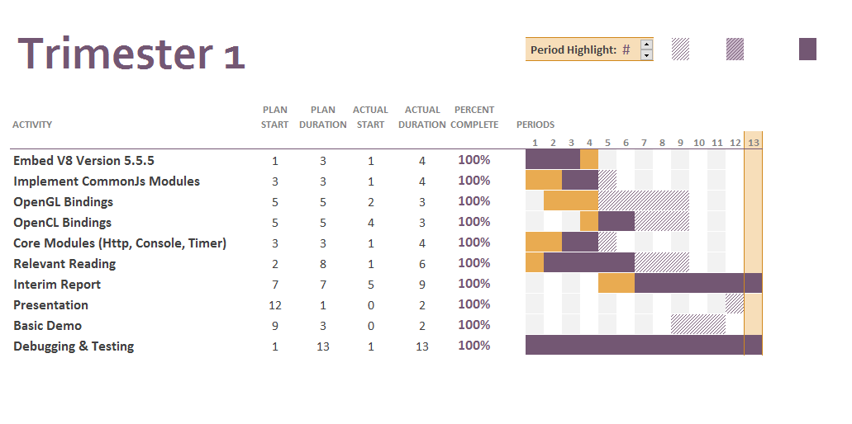To help layout the tasks and work to be done in both trimesters a Gantt chart was created for each trimester. I am very fortunate to have followed these Gantt charts to the letter resulting in a project that was completed earlier than expected. When it came to creating, these Gantt charts a single task was broken down into sub tasks and then assigned to the Gantt Chart. Particularly in Trimester 1 you can see a lot of tasks were finished earlier than expected and that was thanks to a lot of development work being done before the module started.

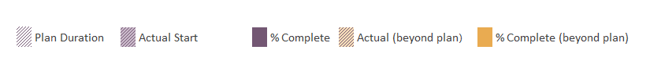

## 

## 1.3 Version Control

As this was a development based project rather than a normal research based project Git was used for version control was used to ensure there was good management of the source code. This not only allows me to manage code more easily but it allows easier troubleshooting and risk management as errors can be tied to an individual commit allowing bugs to be easily found and removed.

## 1.4 Online Repository

Using Git for version control was only one side of the coin. The entire modules source code as well as documents were hosted on GitHub an online git hosting system. GitHub tool not only allows easy tracking of issues through issue management but it gives a great graphical representation of the repository’s progress and workflow state. Below you can find a link to the repository online which is public to anyone who wishes to browse the source code. The graphs you see later in this report are from GitHub which generates graphs and statistics for the repository without any commands need. Also, if people wanted to add to the this honours project they could. They could fork the repository and make they own additions to the platform.

***Online Repository Link:*** <https://github.com/wt-student-projects/computing-honours-project>

## 1.5 Statistics

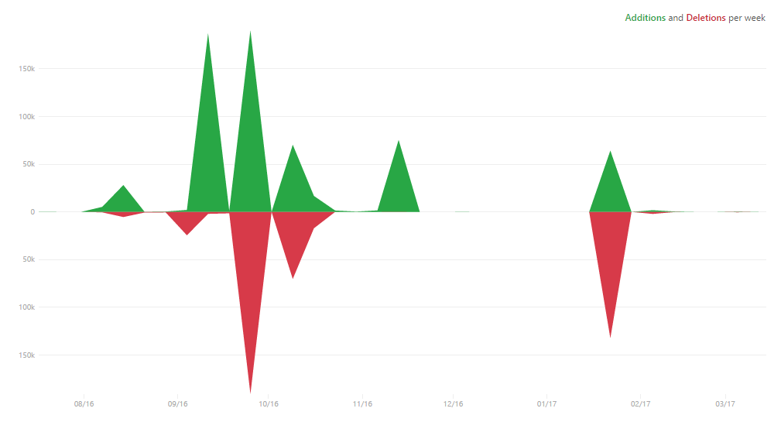These statistics cover my time from when I started the repository and when I handed in my final draft to my supervisor. As is seen I did spend a lot of work on this project and you can see that there are spikes on the contribution graph the relay with the hand in dates for various submissions. You can also see the punch card which breaks down what days I did my work. It is also worth noting that the repository didn’t just house the code for the platform. It contained all documents for the project including the final honours report, project meetings etc. So, the statistics given is for the entire project not just the source code which is why contributions, additions and deletions are so high.

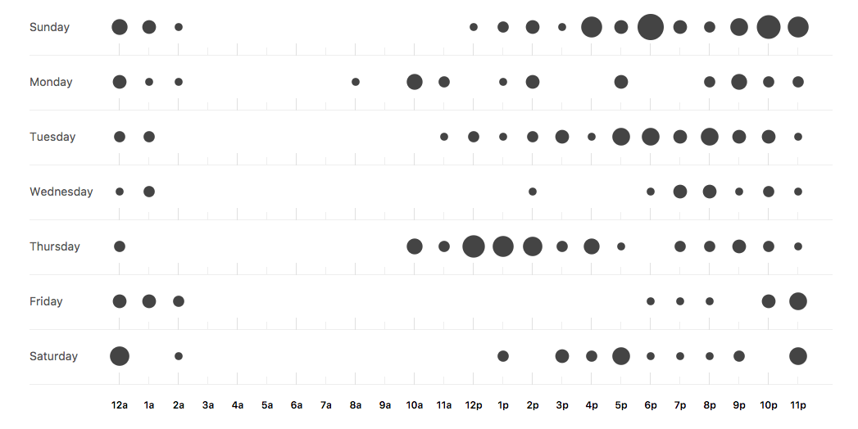

# 2.0 Supervisor Meetings

Regular meeting was held on a fortnight basis.

## 2.1 Meeting 1

### 2.1.1 Meeting Agenda

### 2.1.2 Meeting Minutes

## 2.2 Meeting 2

### 2.2.1 Meeting Agenda

### 2.1.2 Meeting Minutes

## 2.3 Meeting 3

### 2.3.1 Meeting Agenda

### 2.3.2 Meeting Minutes

## 2.4 Meeting 4

### 2.4.1 Meeting Agenda

### 2.4.2 Meeting Minutes

## 2.5 Meeting 5

### 2.5.1 Meeting Agenda

### 2.5.2 Meeting Minutes

## 2.6 Meeting 6

### 2.6.1 Meeting Agenda

### 2.6.2 Meeting Minutes

## 2.7 Meeting 7

### 2.7.1 Meeting Agenda

### 2.7.2 Meeting Minutes

## 2.8 Meeting 8

### 2.8.1 Meeting Agenda

### 2.8.2 Meeting Minutes

# Conclusion

In short I feel this project was managed very well. Work was completed ahead of schedule at every turn which allowed plenty of time to work on fixes to any issues that came up when reviewing the items for submission. Thanks to version control I effectively tracked and managed my software source code much more effectively than I would have otherwise. I had a timeline for my work effectively set out in Gantt charts and in my own plan for the modules completion. I can’t see how it could have been managed better considering items were completed on time in line with the plan I set out.